E-commerce Backend System Using FastAPI
- Project Overview
This E-commerce Backend System is a scalable, modular, and production-ready backend application built using FastAPI. It serves as the backbone of a complete e-commerce platform, handling core functionalities such as user authentication, product management, shopping cart, order processing, and role-based access control.
The system is designed with clean architecture principles and asynchronous programming to ensure high performance, security, and scalability,
User Roles
- User (Customer)
- Can register, login.
- Can browse products listed by admin.
- Can add/remove items to/from cart.
- Can view and update cart items.
- Can checkout and place orders.
- Can view their order history.
- Admin
- Can register, login.
- Can view All products.
- Can view their created products.
- Can create, update, and delete any product.

- Tach Stack
- Language: Python 3.13.4
- Framework: FastAPI
- ORM: SQLAlchemy (Async)
- Database: PostgreSQL
- Authentication: OAuth2 with JWT (access & refresh tokens)
- Mail Service: SMTP

- System Design
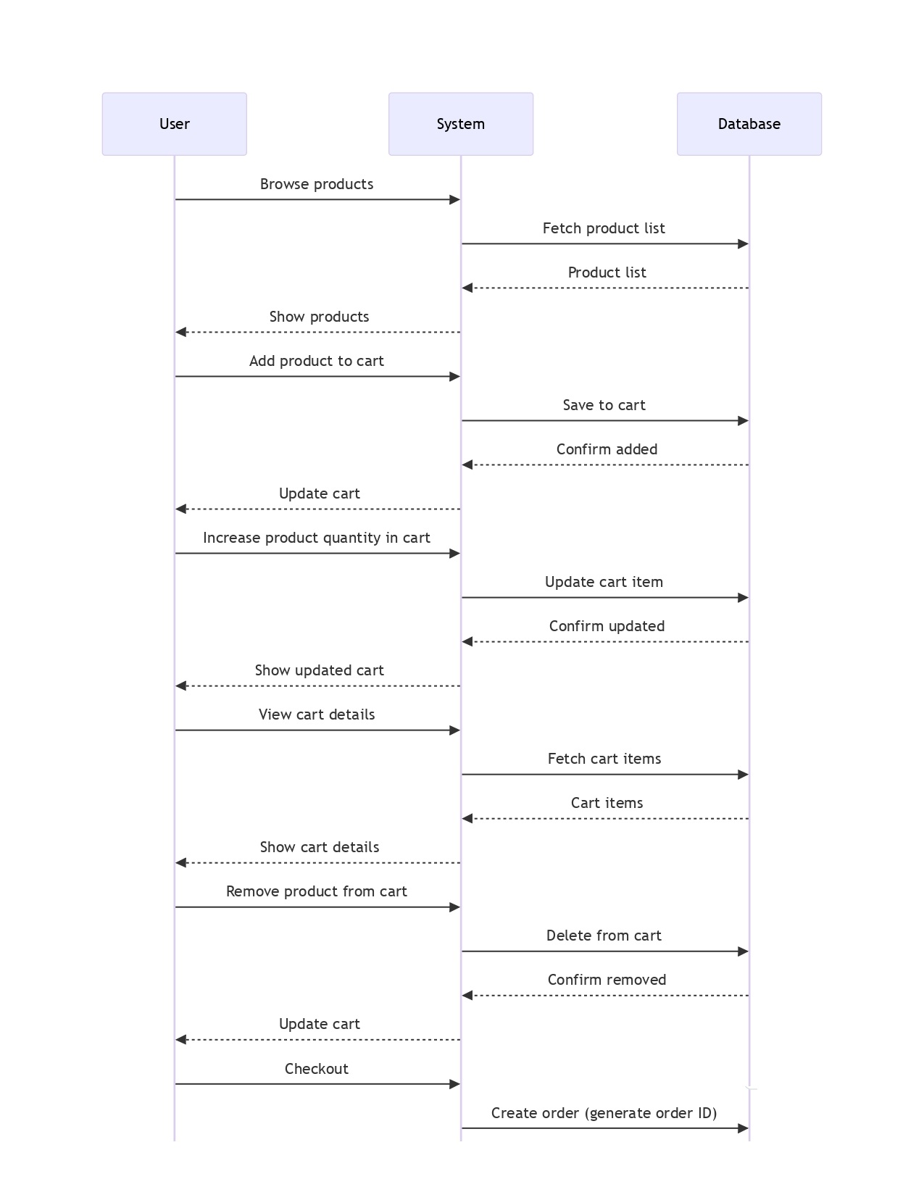
  - Sequence Diagram
User Flow

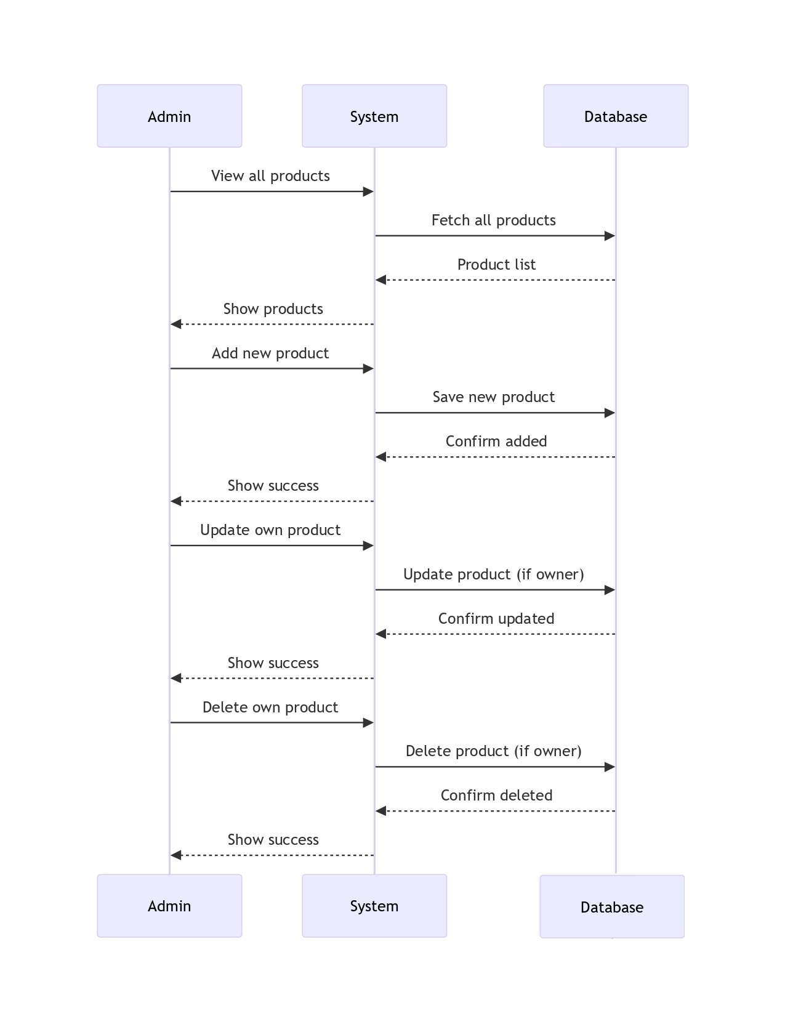
Admin Flow

3.2 Database Diagram
- users: Stores user details with fields like name, email, password, role, and created_at.
- products: Contains product-specific information with fields like name, description, price, stock, category, image_url, is_active, and a foreign key user_id (admin who created it).
- cart_items: Tracks items added to the cart with fields like user_id, product_id, quantity, and created_at.
- orders: Manages order records such as user_id, total_amount, address, status, and created_at.
- order_items: Stores item-level details within an order like order_id, product_id, quantity, price_at_purchase, and created_at.
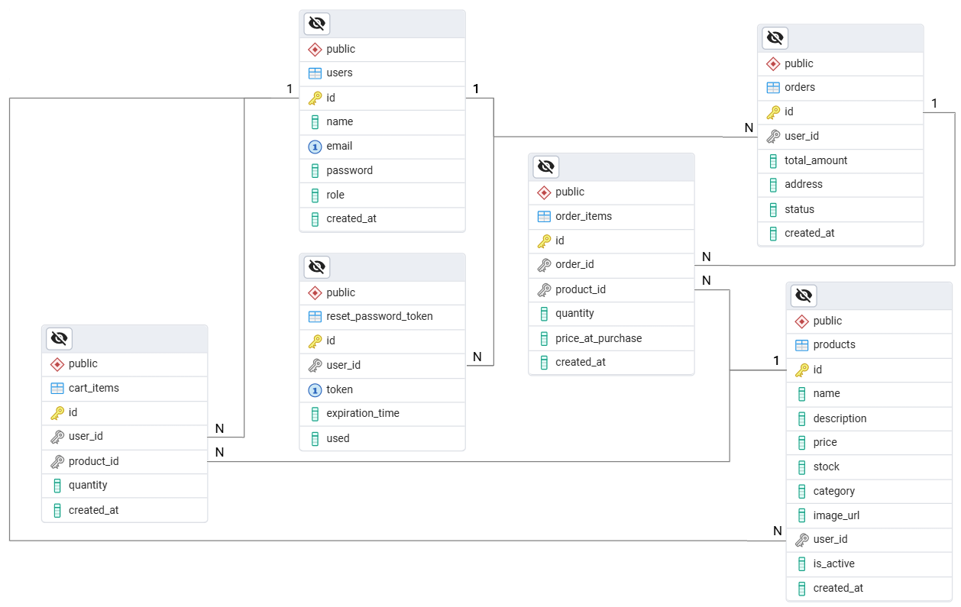
- reset_password_token: Handles password reset flow with fields like user_id, token, expiration_time, used, and id.

4. Project Structure
app/
├── main.py
├── dependency.py
├── exceptions.py
├── global_exception_handler.py

├── configuration/
│ ├── cloudinary.py
│ ├── config.py
│ ├── database.py

│ ├── logger_config.py
├── auth/
│ ├── routes.py
│ ├── models.py
│ ├── schemas.py
│ ├── utils.py
├── products/
│ ├── models.py
│ ├── user/
│ │ ├── routes.py
│ │ ├── schemas.py
│ ├── admin/
│ │ ├── routes.py
│ │ ├── schemas.py
├── cart/
│ ├── routes.py
│ ├── models.py
│ ├── schemas.py
├── orders/
│ ├── routes.py
│ ├── models.py
│ ├── schemas.py
├── middlewares/
│ ├── oauth2.py
│ ├── route.py
│ ├── schema.py
├── utils/
│ ├── send_email.py
│ ├── password_reset_email.py
│ ├── reset_password_token.py
│ ├── image_uploader.py
│ ├── password_encoder.py

- API Endpoints

HTTP Method | Endpoint | Description
POST | /auth/signup | Register a new user.
POST | /auth/signin | Login and generate access/refresh token.
POST | /auth/refresh-token | Get new access token using refresh token.
POST | /auth/forgot-password | Request password reset via email.
POST | /auth/reset-password | Reset password using token.
POST | /admin/products | Create a new product. (Admin only)
GET | /admin/products | View all products. (Admin only)
GET | /admin/products/{id} | Get product details by ID. (Admin only)
PUT | /admin/products/{id} | Update a product. (Admin only)
DELETE | /admin/products/{id} | Delete a product. (Admin only)
GET | /products | View all products. (User)
GET | /products/search?keyword= | Search products by keyword. (User)
GET | /products/{id} | View product details. (User)
POST | /cart | Add product to cart. (User)
GET | /cart | View cart items. (User)
PUT | /cart/{product_id} | Update quantity of product in cart. (User)
DELETE | /cart/{product_id} | Remove product from cart. (User)
POST | /checkout | Dummy checkout, clears cart and creates an order. (User)
GET | /orders | View order history. (User)
GET | /orders/{order_id} | Get details of a specific order. (User)

6. Features and Functionalities
- User Authentication: Secure authentication using FastAPI and JWT.
- Role-Based Access: Role-based actions for Admin and Users.
- Product Management: Admin can manage product inventory.
- Cart System: Users can manage cart items including add, update, remove.
- Order Processing: Orders created on checkout with product details.
- Email Support: Reset password functionality using email tokens.

7. Implementation Details

7.1 User Management
- Registration: Users can register with their basic details. Role is assigned as 'user' by default.
- Login: Users log in using email and password, receive JWT tokens.

7.2 Product Management
- Create Product: Admin can create new products.
- Update Product: Admin can update details of their own products.
- Delete Product: Admin can remove their own products.
- View Products: Admin and users can view product list and details.

7.3 Cart Management
- Add to Cart: Users can add products to their cart.
- Update Cart: Users can increase or decrease quantity of cart items.
- Remove from Cart: Individual products can be removed.
- View Cart: Users can view their cart details.

7.4 Order Management
- Checkout: On checkout, products from the cart are added to an order.
- Order Items: Stores product-wise order info with price snapshot.
- Order History: Users can view past orders and their contents.

7.5 Password Reset
- Forgot Password: Users can request password reset via email.
- Reset Password: Token-based reset system with expiry support.

7.6 Authentication and Authorization
- FastAPI Security: Secured endpoints using FastAPI dependencies.
- JWT Tokens: Tokens used for authentication and session control.
- Role-based Access: Admins can manage products; users can browse, order, and manage cart.
- BCrypt: Passwords are encrypted using bcrypt hashing.

8. Conclusion
This E-commerce Backend System built using FastAPI provides secure and scalable product browsing, cart handling, and order processing functionalities. It leverages role-based access for user and admin roles, along with secure authentication mechanisms. The system is ready for integration with a frontend or mobile app.

